**Strings in C++**

**Strings in C++** are used to store text or sequence of characters. In C++ strings can be stored in one of the two following ways:

* C style string (using characters)
* String class

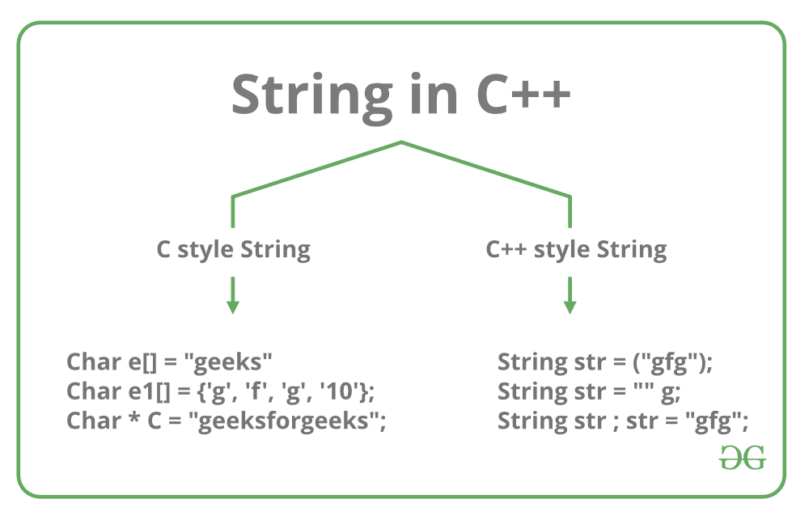

Each of the above methods is discussed below:

1. **C style string:** In C, strings are defined as an array of characters. The difference between a character array and a string is the string is terminated with a special character ‘\0’. In C, the string is actually represented as an array of characters terminated by a null string. Therefore the size of the character array is always one more than that of the number of characters in the actual string. This thing continues to be supported in C++ too. The C++ compiler automatically sets “\0” at the end of the string, during initialization of the array.

**Initializing a String in C++:**

1. char str[] = "Geeks";

2. char str[6] = "Geeks";

3. char str[] = {'G', 'e', 'e', 'k', 's', '\0'};

4. char str[6] = {'G', 'e', 'e', 'k', 's', '\0'};

Below is the memory representation of a string “Geeks” in C++.

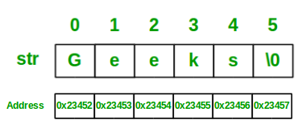

Let’s look at some examples to better understand the string representation in C++, using C style:

C++

// C++ program to demonstrate

// Strings using C style

#include <iostream>

using namespace std;

int main()

{

// Declare and initialize string

char str[] = "Geeks";

// Print string

cout << str;

return 0;

}

**Output**

Geeks

**Standard String representation and String Class:** In C++, one can directly store the collection of characters or text in a string variable, surrounded by double-quotes. C++ provides string class, which supports various operations like copying strings, concatenating strings etc.

**Initializing string in C++:**

1. string str1 = "Geeks";

2. string str2 = "Welcome to GeeksforGeeks!";

**Example:**

C++

// C++ program to demonstrate String

// using Standard String representation

#include <iostream>

#include <string>

using namespace std;

int main()

{

// Declare and initialize the string

string str1 = "Welcome to GeeksforGeeks!";

// Initialization by raw string

string str2("A Computer Science Portal");

// Print string

cout << str1 << endl << str2;

return 0;

}

**Output**

Welcome to GeeksforGeeks!

A Computer Science Portal